
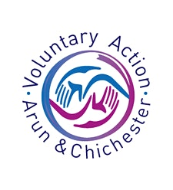
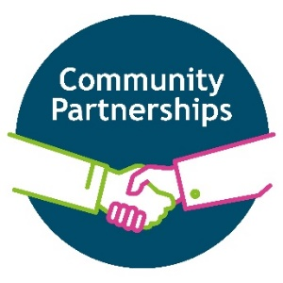

How a Community Organisation Adapted During the COVID-19 Crisis

August 2020
By working with our colleagues in the Voluntary and Community sector, we have a series of reports on our website that capture the experiences and issues from the point of view of services and groups that support local people in the community.
This is an independent case study showing an example of one community organisation’s story of adapting and what the future holds.


About the organisation
The Friends are proud to be entirely volunteer led and operate, supporting St Richard’s Hospital and local mental health services.


All of the money we raise goes directly to making a real difference for patients, visitors and staff.
Jane Ramage

What were the immediate challenges?
Friends of Chichester Hospital began thinking about the effect of COVID-19 about a month before the Government announcements. They began doing extra cleaning activities – hand washing - and purchased hand sanitiser to support infecton control regimes and to keep volunteers safe.
When the Government announced that people over 70 years should shield or self-isolate they received a flood of phone calls. Some stopped immediately, and some at the end of that week, and within two weeks all volunteers had stopped.
It is very difficult to protect and socially distance in the shop. To run the shop they need six volunteers, the hospital trolley service also stopped as they come into contact with patients. They closed the hospital shop and removed all perishable item and returned around a month later to check on stock.

How has this impacted on volunteers and patients/service users?
The shop management team, all volunteers, stayed in touch with the volunteers and the office volunteers helped to keep morel up. In reality most knew it would take a while for things to get back to normal.
It has been difficult for staff working at the hospital and some were unhappy we closed as they used the shop for snacks and lunches. The hospital remaining facilities were limited, and Costa coffee closed down. People began to bring in gifts of meals and chocolates.
The impact on patients/service users was enormous as there were few non COVID-19 patients and family and friends could not visit. Occupational Health asked them to provide newspapers and puzzle books to support the mental health of patients. They took an order for an item and this was delivered to the ward. This meant a lot to the patients. For the COVID-19 patients who were beginning to feel a little better but not yet 100% having something to simulate the mind was helpful. They were not allowed near the wards.
Visiting patients is not back to normal and the hospital is deathly quiet. The outpatient’s services are open but with limited numbers with social distancing waiting areas. Patients are only allowed to bring one person with them to appointments.
Volunteers may decide not to come back because of the risks. Currently some volunteers are too scared to even go out for a walk in the park.

How has COVID affected their finances?
Friends of Chichester Hospital believe the financial loss of the pandemic to be around £20,000, as they have received some unexpected donations. They do not have any staff salaries to pay as the whole service is run by volunteers.

They did apply for some grants and made applications to small business. They were successful with a Spirit FM grant scheme. They also secured a grant to pay for a month of commercials - six clips a day for four-weeks and this finishes the end of August.
They have provided more funding for care in mental health than normal. People are struggling because of COVID-19 and providing creative and therapeutic communications to respond to isolation.
We have not yet seen a specific item request that is unaffordable at the moment.

How will social distancing impact on your service?
Friends of Chichester Hospital contacted the hospital as soon as the Government changes to the lockdown began to discuss things with the Trust. The Trust stopped all volunteers over 70 years from returning. Advice on disinfectant, sanitation, and reorganising the layout of the hospital shop, till area screen and hand sanitiser advice was provided. The Trust provided masks for every volunteer and they supplied hand sanitiser. So, from the 6th July they re-opened for four hours for five days a week.
The hospital is incredibly quiet, but things are beginning to build up. The hospital has continued, in reduced form to provide non-COVID-19 services such as maternity. The staff are not yet back to normal but those who have visited the shop are please they are back. At present, many hospital staff were redeployed to other areas, staff are bringing in their own lunches and eating in a different area and many staff are on leave before the anticipated next wave.
Until the restriction on the over 70 years volunteers are lifted, they are not able to offer a longer service. They have recruited 4-5 new volunteers but are not yet able to train or recruit others. They do have volunteers from the university but expect them to stop once the university returns.
COVID-19 is the scariest thing in our lifetime event with the Second World War.

Their office is small and very difficult to social distance and the trolley service is mothballed. The trolley service provided the human face as the only non-clinical interaction all week.
So, they are in semi-limbo with a foot in the door – the shop is open.

What are the concerns for the future, post COVID?
Charities generally have suffered huge financial losses and need to be agile during this time, be flexible for patients. They do not have the urgency of paying salaries and are in a fortunate position. But patients/service users are still being affected.

Contact details
To learn more about call 01243 831843
Email admin@friendsofchichesterhospital.org.uk
Or visit their webpage https://www.friendsofchichesterhospitals.org.uk/

