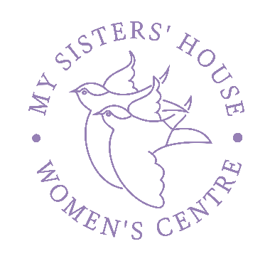
Press Release:
My Sisters’ House CIC Women’s Centre - Patron Dame Julie Walters DBE and CEO Julie Budge appear on National Television on Good Morning Britain – Live with Lorraine – Thursday 21st May 2020

The context:

- Dame Julie Walters as Patron of My Sisters ‘House Women’s Centre in West Sussex with their CEO Julie Budge talking about women suffering domestic abuse in Lockdown.
- We, like all charities, have been playing a part in this battle to help meet vital and increasing needs of women and families in the community in the face of Covid19.
- We have adapted and extended our services during the lockdown with 3 new helplines, including the only out of hours service and Live Chat in West Sussex.
- To see the recording of the ITV appearance, go to our website and click donate:
www.mysistershouse.info/press

The messages we wanted to give, but were not able in the entirety:
- Your voice matters, your feelings & thought’s matter, you matter, your life matters – please ask for help. #you are not alone campaign.
- There is a National 24hr Domestic Abuse helpline 0808 2000 247 and lots of other organisations who can help. For West Sussex see www.safespace.org.uk
- Reach out to family let them know, tell them you will send a certain emoji or phrases if the risk is higher and you need help urgently.
- That they can download app’s that can activate the police if ‘man down’ like the Holly Guard.
- What wonderful things women’s centre like us do centre – advice, guidance, information, peer groups, training, emergency provision, domestic abuse service, back to work support and counselling – a wraparound women centred ethos!
- We are community. It is not just ‘their’ business but everyone’s. Stay alert, is it someone you know. Say something. Do something.
Julie Budge: “It was an amazing experience to be on national television, be it via skype. I felt proud to see both names My Sisters’ House & Bognor Regis coming up on the screen and bring the plight of domestic abuse to the fore – as it should be. I was disappointed not to have got all my points across but in a way, the mere fact that we got some points across may have helped more women stay safe”

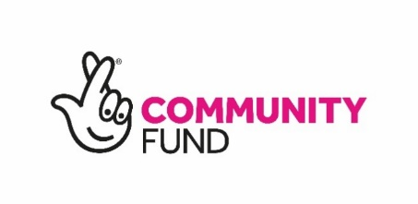
Embedded in the Bognor Regis community, My Sisters’ House Women’s Centre, now a Registered Charity works across the coastal area of West Sussex. We provide a wide range of support needs to women from all backgrounds facing all kinds of issues where their strengths are recognised, their difficulties acknowledged and where they can achieve positive change, they are proud of.

We provide an independent frontline service, co-produced by local women, safe, supportive and community-based, trauma informed, holistic and in a gender specific way. We provide Information & Signposting, Advice & Support, Individual Casework / Complex Casework, Grow Skill & Confidence and Enable access to volunteering & work.

Notes to editor:
Website : www.mysistershouse.info Facebook : www.facebook.com/mysistershouseuk
Address : My Sisters’ House CIC 108b & c London Road, Bognor Regis, West Sussex PO21 1AE Julie Budge : CEO/ Founder 0742 765 1820 : julie.budge@mysistershouse.info or additional photo’s please contact CEO.

